Department of Computer Science and Engineering (Data Science)
CSDS-A | Batch A4 (CSE - Data Science, Section A)
Advanced Optimization in E-Commerce Logistics: Combining Matheuristics With Random Forests for Hub Location Efficiency
(HubOptima)
S.No. | Student name | Roll / hall ticket no.
1 | CH.ARCHANA | 23K91A6745
2 | A.MEENAKSHI | 23K91A6705
3 | B.ARUN | 23K91A6734
4 | A.SAMPATH | 23K91A6712
Under the guidance of: [GUIDE NAME], [DESIGNATION]
METHODOLOGY, NOVELTY AND KEY CONTRIBUTIONS
This document describes how HubOptima works from end to end, why its algorithms were chosen, what is new in it compared with the base paper, and the contributions of the project. All figures are measured values from the project's own saved models and results, produced on a synthetic dataset.

1 Overall Methodology
The methodology follows the predict-then-optimise framework of the base paper [1] in eight stages. Each stage is a function of the hublocator package and a node of the data-flow diagrams in Chapter 5.
Table 1: Methodology stages
Stage | What happens | Module
1 Data | A seeded generator produces 90 regions and 36 months of orders; loading de-duplicates and fills gaps | data.py
2 Features | Lags 1, 2, 3, 6 and 12, rolling mean and standard deviation, trend, season, promotion and region attributes (19 features) | forecast.py
3 Forecaster | A Random Forest of 400 trees is trained on 2023-04 to 2025-06 and tested on 2025-07 to 2025-12 | forecast.py
4 Forecast | Next-month demand per region from the lag features; for a past month only earlier data is used | forecast.py
5 Model | Distances, delivery times, unit costs, fixed costs by tier and hub capacity form an Instance | model.py
6 Solve | Matheuristic (greedy construction, MIP-priced local search, kernel search) or the exact MIP | matheuristic.py, model.py
7 Evaluate | KPIs of the plan are computed on the realised demand: cost, delivery time, fulfilment, reliability, utilisation | model.py
8 Compare and adapt | Baselines, a scalability benchmark and a month-by-month rolling horizon | baselines.py, rolling.py

Plan, then judge. A plan is built from a forecast and judged on the realised demand. Capacity is sized from the planned demand, so if the realised demand is higher some hubs are overloaded and fulfilment falls below 100%. This separation is the heart of the evaluation and is how the effect of forecast error on the hub decision is made visible.

2 Dataset
No public region-level order dataset is referenced by the project and no company data was available, so the dataset is synthetic. It is produced by generate_dataset(seed=42) in hublocator/data.py and shipped in data/. All results in this report are produced on it and must be read with that in mind: the forecaster learns a demand process that the authors themselves wrote down.
Table 2: Dataset facts
Property | Value
Source | Generated by the project (seed 42); city coordinates and populations are approximate public values; no third-party licence applies
Regions | 90 = 30 Indian cities (tier 1: 8, tier 2: 14, tier 3: 8) plus 60 satellite districts 45-160 km away (3 per tier-1 city, 2 per tier-2, 1 per tier-3); 68 regions are tier 3 in total
History | 36 months, 2023-01 to 2025-12; 3,240 region-month rows
Total orders | 48,295,881; per region-month from 218 to 321,460
Network volume | 1,002,122 orders in 2023-01; peak 2,383,534 in 2025-10; 1,593,341 in 2025-12
Demand process | population x tier-specific penetration / 12, monthly growth 1.0-2.2%, festival multipliers (Oct 1.35, Nov 1.25, Jan 1.08, Aug 1.10), 0.93 in Feb and Jun, a promotion flag (18% random, always in Oct and Nov) with a 14% lift, and Gaussian noise with 6% standard deviation
Columns | demand_history: region_id, period, year, month, orders, promo, avg_order_value, avg_parcel_weight_kg, return_rate. regions: region_id, city, state, lat, lon, population, tier, parent, penetration
Split | Time-based: train 2023-04 to 2025-06 (2,430 rows), test 2025-07 to 2025-12 (540 rows). No random split, no cross-validation

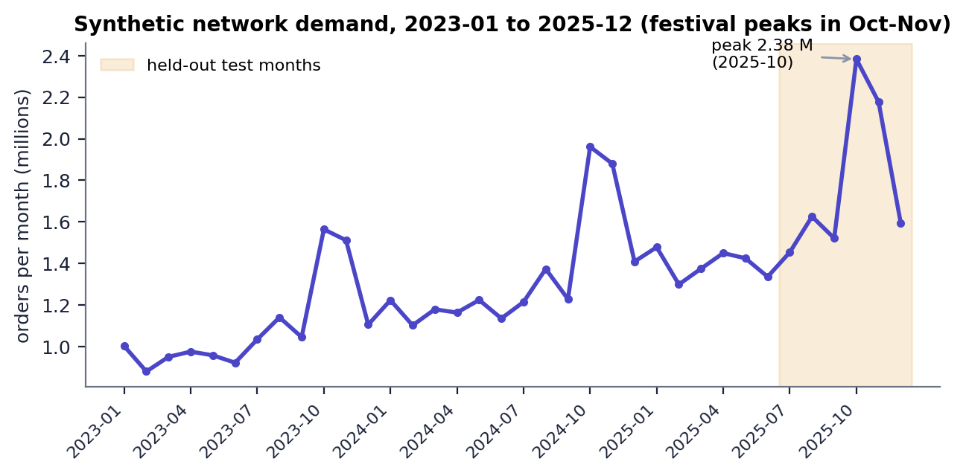
Fig. 1: Monthly network demand of the synthetic dataset, with the six test months shaded
The tier counts above count cities by their tier in the CITIES table; satellite districts are all tier 3, which is why 68 of the 90 regions are tier 3. Festival peaks in October and November and the upward trend are visible; the October 2025 peak (2.38 million orders) is higher than any earlier month, which matters for forecasting (see Chapter 8).

3 Data Preprocessing and Feature Engineering
Preprocessing is done by load_dataset and build_features. Because the generated data is complete, most guards are inactive; they exist so a real file of the same schema can be used.
1. Convert period to text and drop duplicate (region, period) rows.
2. Convert orders to numbers (non-numeric values become missing), sort by region and period.
3. Interpolate missing orders inside each region (both directions), then drop rows that are still empty and cast orders to integers.
4. Derive year and month from period if absent; give tier and penetration defaults if absent.
5. Merge the region attributes (population, tier, penetration) into the demand rows.
6. Per region, create lag features of orders at 1, 2, 3, 6 and 12 months; where the 12-month lag is not available it is filled with the 6-month rolling mean.
7. Create the rolling mean over 3 and 6 months and the rolling standard deviation over 3 months, all computed on values shifted by one month so that the current month never leaks into its own features.
8. Create trend_3 (lag 1 minus lag 3), quarter, festival (October, November, January, August) and the promotion flags for the month and the previous month.
9. Drop rows without the 3-month lag or rolling mean (the first months of each region).
Table 3: The 19 features of the forecaster
Group | Features
Lags | lag_1, lag_2, lag_3, lag_6, lag_12
Rolling | roll_mean_3, roll_mean_6, roll_std_3, trend_3
Calendar | month, quarter, festival
Promotion | promo, promo_prev
Region | population, tier, penetration
Market | avg_order_value, return_rate

The excerpt below is the lag and rolling-window part of build_features; the shift(1) before every rolling window is what keeps the features free of look-ahead.
Listing: hublocator/forecast.py - build_features
def build_features(regions: pd.DataFrame, demand: pd.DataFrame) -> pd.DataFrame:
df = demand.merge(regions[["region_id", "population", "tier", "penetration"]], on="region_id")
df = df.sort_values(["region_id", "period"]).copy()
g = df.groupby("region_id")["orders"]
for k in (1, 2, 3, 6, 12):
df[f"lag_{k}"] = g.shift(k)
df["roll_mean_3"] = g.transform(lambda s: s.shift(1).rolling(3).mean())
df["roll_mean_6"] = g.transform(lambda s: s.shift(1).rolling(6).mean())
df["roll_std_3"] = g.transform(lambda s: s.shift(1).rolling(3).std())
df["trend_3"] = df["lag_1"] - df["lag_3"]
df["quarter"] = (df["month"] - 1) // 3 + 1
df["festival"] = df["month"].isin(FESTIVAL_MONTHS).astype(int)
df["promo_prev"] = df.groupby("region_id")["promo"].shift(1)
df["lag_12"] = df["lag_12"].fillna(df["roll_mean_6"])
return df.dropna(subset=["lag_3", "roll_mean_3"]).copy()

4 Algorithm Choice and Justification

4.1 Random Forest for demand
A Random Forest [11] averages many decision trees, each grown on a bootstrap sample with a random subset of features at every split. It was chosen for the reasons given by the base paper [1] and for four practical ones: it handles the non-linear effects of season and promotion without feature scaling, it gives feature importances that a planner can read, it is robust to the noise in monthly demand, and it trains in under a second on 2,430 rows. Gradient boosting, neural networks and classical time-series models were not tried; the choice is therefore justified by the base paper and by the result against naive benchmarks, not by a tournament of models.

4.2 Capacitated hub-location MIP
The hub model is a mixed-integer program solved by CBC [15] through PuLP [14]. An exact MIP gives a quality reference: when it finishes, the plan is optimal for the model. It is also the building block of the heuristic.

4.3 Matheuristic
The full model has n + n^2 binary variables (8,190 for 90 regions, 73,170 for 270). Fixing the set of hubs, however, leaves only an assignment problem with n x |H| variables (540 for six hubs), which CBC solves quickly. The matheuristic therefore searches over hub sets and prices each set exactly [12]. Screening with a cheap estimate avoids most pricing calls, and a final kernel search [17] solves the full MIP over only about 24 candidate sites. Variable Neighbourhood Search [16], named in the base paper, was not implemented; the project's local search uses swap, drop and add neighbourhoods with first improvement.

4.4 Baselines
Table 4: Baseline methods
Method | How it chooses hubs | Why it is included
Greedy heuristic | Open the hub that most lowers the uncapacitated cost, repeat; allocate by capacity-aware nearest hub | Fast heuristic used in practice; no quality guarantee
k-means clustering [18] | Demand-weighted k-means on coordinates; hub = region nearest each centre | Standard clustering approach to hub placement
Largest-markets rule | Hubs at the p regions with the largest demand | Managerial judgement, no optimisation
Historical-average + matheuristic | Same solver but planned on the average of earlier months, with no forecast | Isolates the value of forecasting
Exact MIP | Full MIP with a time limit | Traditional exact method and optimality reference

5 Mathematical Formulation

5.1 Inputs derived from the data
Regions are indexed i, j = 1..n (n = 90); every region is a candidate hub site. With D_i the planned demand (forecast) of region i:
a = sin^2(dphi/2) + cos(phi_i) cos(phi_j) sin^2(dlambda/2)
dist_ij = 1.25 x 2R asin( sqrt(a) ), R = 6371 km (1)
t_ij = dist_ij / v + h (i != j), t_ii = h / 2 (2)
c_ij = r dist_ij + lambda t_ij (3)
f_j = F m(tier_j), m = 1.35, 1.0, 0.75 for tiers 1, 2, 3 (4)
C = kappa SUM_i D_i / p (5)
with v = 45 km/h, h = 6 h, r = INR 0.04 per order-km, lambda = INR 1.5 per order-hour, F = INR 2,500,000 per month, kappa = 1.25 and p = 6. The haversine formula [20] gives great-circle distance; the factor 1.25 turns it into an approximate road distance.

5.2 Optimisation model
Binary y_j = 1 if a hub is opened at j; binary x_ij = 1 if region i is served by hub j.
minimise SUM_j f_j y_j + SUM_i SUM_j c_ij D_i x_ij (6)
subject to SUM_j x_ij = 1 for every i (7)
x_ij <= y_j for all i, j (8)
SUM_i D_i x_ij <= C y_j for every j (9)
SUM_j y_j <= p (10)
x_ij = 0 whenever t_ij > SLA (optional hard service level) (11)
x_ij, y_j in {0, 1}
Equation (7) gives every region exactly one hub, (8) lets only open hubs serve, (9) is the hub capacity and (10) limits the number of hubs to p. The objective has three parts: a fixed hub cost, a transport cost proportional to distance and a delivery-time penalty. With a soft SLA (the default) late deliveries are only penalised through the time term and reported by the reliability KPI; with a hard SLA constraint (11) forbids them, which can make the problem infeasible. Compared with the base paper's model this one has a single capacity level, no unmet-demand variable and no robust objective.

5.3 Evaluation measures
A plan is a pair (H, a) of the hub set and the assignment a(i). Given the realised demand R_i, the load of hub j is L_j = SUM over i with a(i) = j of R_i, and the share a hub can serve is s_j = min(1, C / L_j). The KPIs are:
total cost = SUM_{j in H} f_j + SUM_i r dist_{i,a(i)} R_i + SUM_i lambda t_{i,a(i)} R_i (12)
average delivery time = SUM_i t_{i,a(i)} R_i / SUM_i R_i (13)
fulfilment = SUM_i s_{a(i)} R_i / SUM_i R_i (14)
SLA reliability = SUM_i 1[t_{i,a(i)} <= SLA] s_{a(i)} R_i / SUM_i R_i (15)
utilisation of hub j = L_j / C; overloaded hub: L_j > C (16)
Fulfilment and reliability are model quantities: a hub is assumed to process at most C orders, and the excess is counted as not fulfilled. They are not measured deliveries.

5.4 Forecast measures
On the test rows, MAE = mean |y - yhat|, RMSE = sqrt(mean (y - yhat)^2), MAPE = 100 x mean( |y - yhat| / max(y, 1) ) and R^2 = 1 - SS_res / SS_tot, following common practice [19].

6 Core Algorithm Flowchart
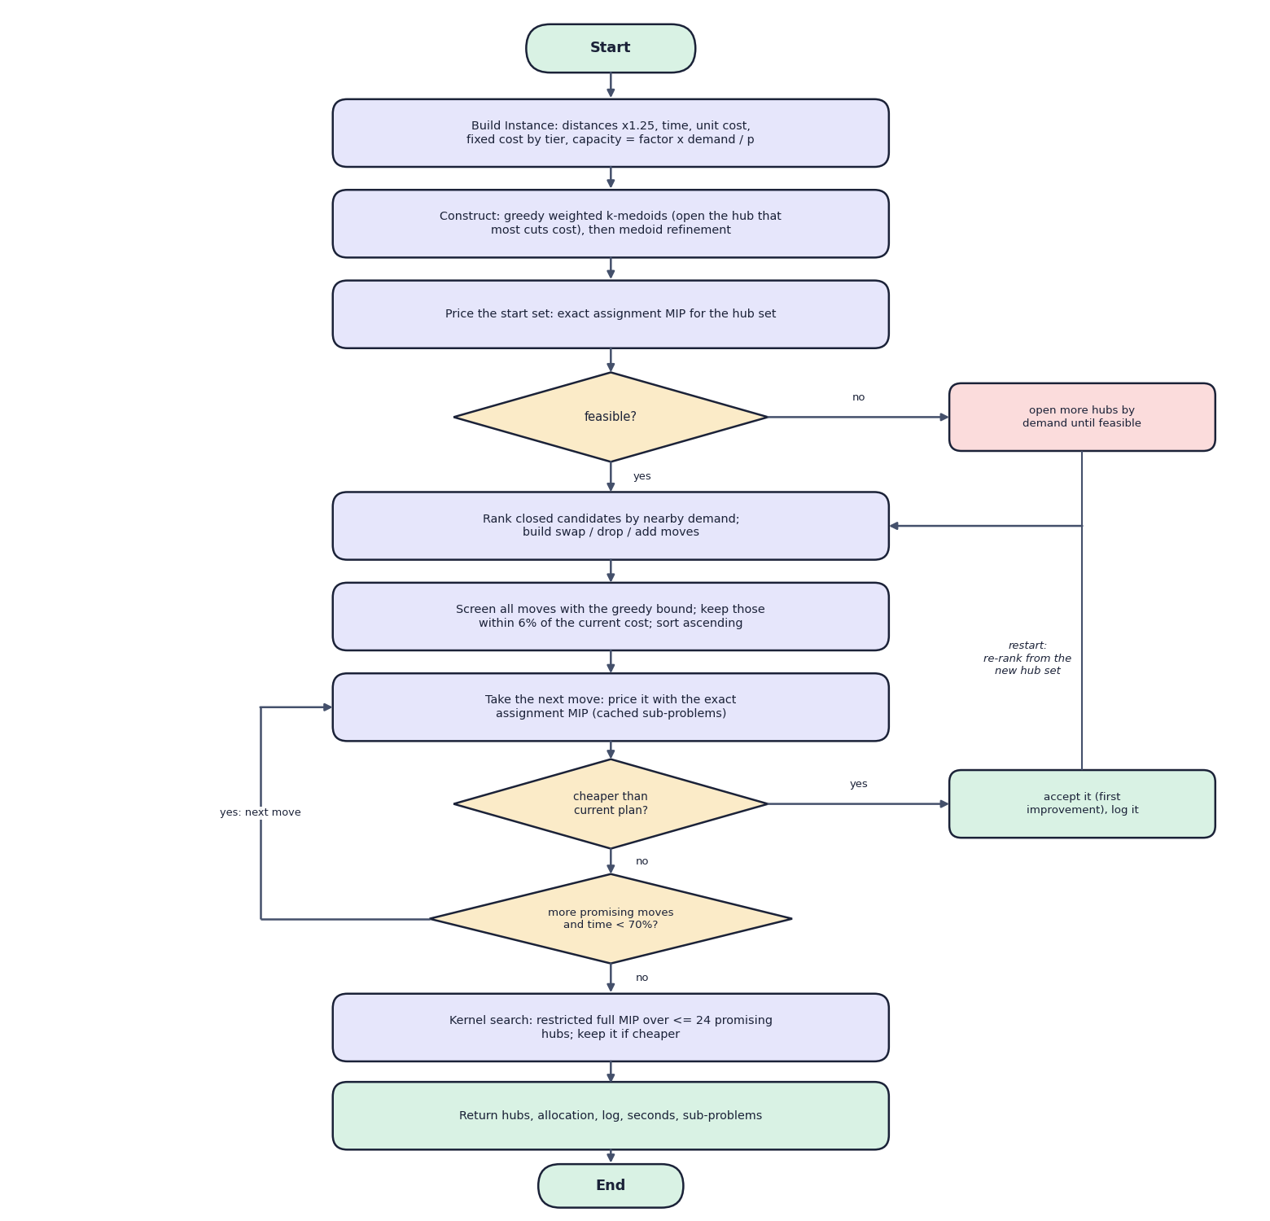
Fig. 2: Flowchart of the core algorithm: the matheuristic
The instance is built and a start set is constructed by a greedy weighted k-medoids rule followed by medoid refinement. It is priced by an exact assignment MIP; if it is infeasible, more hubs are opened by demand until it is feasible. The local search then ranks closed candidates, builds swap, drop and add moves, screens them with a greedy bound, and prices the best-screened move; a cheaper plan is accepted (first improvement) and the search restarts. When no promising move remains or 70% of the time is spent, the kernel search polishes the result and the best plan is returned.

7 Model Architecture and Training Configuration
Table 5: Random Forest configuration
Setting | Value
Model | scikit-learn RandomForestRegressor 1.4.2
Trees | 400 (n_estimators)
Depth / leaf | max_depth None; min_samples_leaf 2
Features per split | max_features 0.6 (60% of the 19 features)
Parallelism / seed | n_jobs -1; random_state 42
Target | orders of the region in the month (not log-transformed)
Training data | 2,430 rows, 2023-04 to 2025-06
Test data | 540 rows, 2025-07 to 2025-12 (never used for fitting)
Fit time | 0.8 s on an Intel Core i5-12500
Tuning | None: hyper-parameters were set once by the authors; no grid search and no cross-validation
Persistence | joblib file of the model and the feature list (38.5 MB); metrics in forecast_metrics.json

Optimiser configuration. Defaults come from config.DEFAULTS: p = 6, capacity factor 1.25, transport rate 0.04, fixed hub cost 2,500,000, time penalty 1.5, truck speed 45 km/h, handling 6 h, SLA 48 h (soft), time limit 20 s per MIP call. Matheuristic internals: kernel size 24, sub-problem limit 5 s, screening tolerance 6%, local search stops at 70% of the time limit. The scalability benchmark uses a 30 s matheuristic limit and a 40-45 s exact limit.

8 Analysis of the Base Paper
Reference. K. Danach, A. Rammal, I. Moukadem, H. Harb and A. Nasser, 'Advanced optimization in e-commerce logistics: Combining matheuristics with random forests for hub location efficiency,' IEEE Access, vol. 13, pp. 55915-55926, 2025 [1]. The paper was received on 3 February 2025 and accepted on 9 March 2025, and is open access.

8.1 Problem and model
The paper studies the HLP for e-commerce distribution networks with centralised hubs, dynamic demand, capacity constraints, service-level requirements, cost minimisation and risk. The formulation minimises the fixed cost of opened hubs, the variable transport cost and a penalty on unmet demand; flows y_ij are continuous, hubs x_i and capacity levels z_ik are binary, capacity constraints bind the flow into each hub, demand constraints require every demand point to be served, and valid inequalities tighten the model (activation, single-allocation, demand-splitting limits).

8.2 Solution approach
The paper combines a Random Forest and a matheuristic. A relaxed MILP provides an initial solution; Variable Neighbourhood Search improves it; a Random Forest trained on historical demand forecasts the future demand at each location; the forecasts are fed back so the hub locations and capacities are re-optimised; finally the solution is validated on test scenarios (peak demand, sudden spikes, route disruptions). The paper also says the Random Forest assists in tuning matheuristic parameters and in scenario analysis.

8.3 Data and experiments
The experiments use a proprietary dataset of a global transport company with thousands of customer locations, several candidate hub sites, two years of demand history, transport costs and hub capacities. Scalability was tested on networks of 50 to 500 nodes.

8.4 Reported results
Table 6: Results reported by the base paper
Indicator | Value reported in [1]
Delivery-time compliance | 92.3% on average (+7.8% over traditional methods in the abstract)
Fulfilment rate | 97.6% on average (+9.4% in the abstract)
Network robustness | 0.87 (+16% in the abstract)
Operating-cost reduction | 15-20% against benchmarks
Scalability | networks up to 300 nodes within reasonable time; near-optimal for up to 500 nodes

8.5 Strengths
- The idea of replacing the fixed-demand assumption by an explicit forecast is simple and practical.
- It states the limits of the study plainly (sector-specific data, offline evaluation, scalability not extensively tested).
- It points to clear extensions: other learners, real-time IoT data, explainable AI, sustainability objectives.

8.6 Gaps that this project addresses
- The dataset, code and matheuristic parameters are not available, so the results cannot be reproduced; this project ships code, a seeded dataset and saved results.
- The sentence on the Random Forest's gain reads 'improves the predictive accuracy by X %'; this project measures the gain against two naive forecasters on a time-based hold-out.
- The paper does not show how forecast error affects the plan; this project scores each plan on realised demand and reports the overloaded hubs.
- No application is provided; this project adds a usable web interface.

9 Novelty Against the Base Paper
The base paper [1] describes the framework and reports service-level results on a proprietary dataset. It does not publish code, the dataset or the parameters of its matheuristic. The table lists what this project adds or does differently. None of it is a claim of better performance than the base paper: the datasets are different and the paper's figures cannot be reproduced.
Table 7: Base paper and this project compared
Aspect | Base paper [1] | This project
Data | Real logistics data of a global transport company (two years, thousands of customer locations); not public | Synthetic data, 90 regions x 36 months, generated by a seeded script and shipped with the code
Forecast model | Random Forest, with hyper-parameter tuning and cross-validation stated; the improvement over statistical methods is left as 'X %' | Random Forest with fixed parameters, time-based hold-out, compared with two naive forecasters; all numbers reported
Matheuristic | MILP for an initial solution, then Variable Neighbourhood Search (VNS) | Greedy/k-medoids construction, swap/drop/add local search priced by exact assignment MIPs after a greedy-bound screen, kernel search; no VNS
Model | Multiple capacity levels, unmet-demand penalty, scenario-based robust objective | Single capacity level, soft or hard SLA, time penalty; no robust objective
Evaluation | Delivery-time compliance 92.3%, fulfilment 97.6%, robustness 0.87; networks of 50-500 nodes | Cost, delivery time, simulated fulfilment and SLA reliability on realised demand; 90-270 nodes; no robustness measure
Adaptation | Re-optimisation described; temporal effects modelled by time-dependent constraints | Rolling-horizon simulation over six months with a static plan as the control
Delivery | Paper only | Open code, tests, 14-endpoint API and a web application

10 Contributions
1. An end-to-end, reproducible implementation of predict-then-optimise (data preparation, Random Forest forecast, capacitated hub MIP, matheuristic, KPI evaluation) in about 2,000 lines of Python, with a fixed random seed and saved models and results.
2. A matheuristic with a screening bound. Swap, drop and add moves are first screened with a cheap greedy cost bound and only the promising ones are priced by an exact assignment MIP; a kernel search then polishes the result. It matched the exact optimum on the 90- and 180-node instances (gap 0.00% and -0.05%) and ran in 3.1 s and 8.3 s against 12.7 s and 42.9 s for the exact MIP.
3. A no-look-ahead evaluation protocol. For a past month the forecaster sees only earlier data, plans are made on the forecast and scored on the demand that actually occurred, so capacity overload caused by forecast error is visible (3 of 6 hubs overloaded in the October 2025 peak). Six methods are compared on the same instance: relative to the proposed plan, the greedy plan costs 11.5% more, k-means 3.6% more, the largest-markets rule 16.1% more and planning without a forecast 8.1% more.
4. Rolling re-optimisation. Re-forecasting and re-planning every month gave 98.3% average simulated fulfilment against 83.7% for a static plan, at 4.9% lower average operating cost, with one hub change in six months.
5. A usable product. A FastAPI layer (14 endpoints, background jobs) and a React application (landing page, dashboard, forecast, plan, compare, re-optimise, regions) that run the same code as the command line; 4 test functions and 18 API smoke checks pass.

